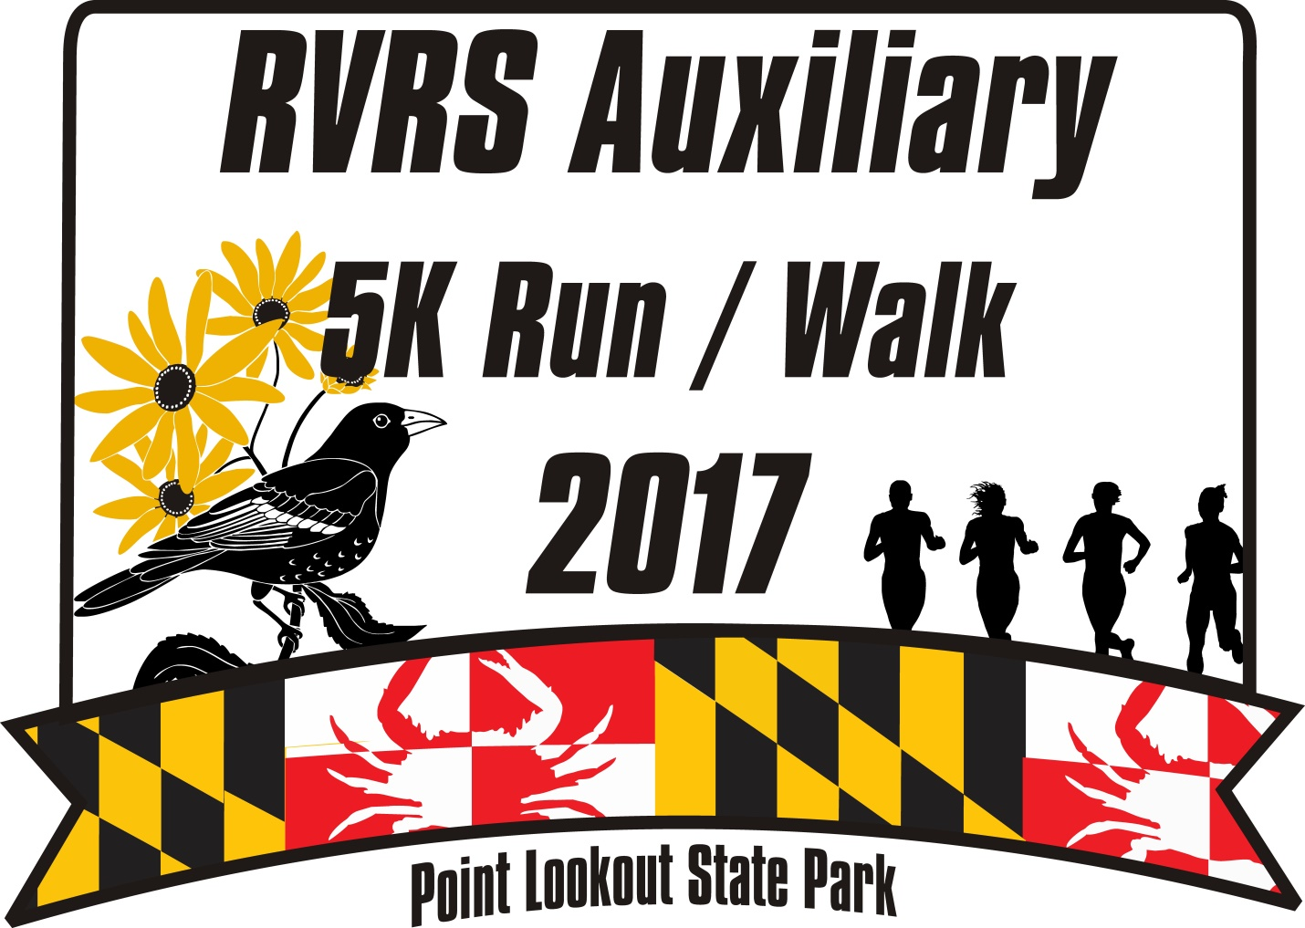
SATURDAY MAY 20, 2017
8:00 a.m.

Racing Awards:
5K Run Awards – Overall top male & female, and top three in each male and female age group
Divisions:
Male & female under 16, 16-19, 20-29, 30-39, 40-49, 50-59, 60+
Course Layout:
A 5K out and back course through scenic Point Lookout State Park
Entry Fees:
$30 if postmarked by 5/13/17; $35 day of race; $5 discount given to CBRC Members
Race Day Registration:
Saturday, May 20th at Point Lookout State Park, 6:30-7:50 a.m.

Race Info: Check out the race website: https://ridgerescuesquadauxiliary5k.eventbrite.com
or call 301-904-2812

Register Early!!!!
First 100 paid entrants receive free event T-shirt!

Additional donations encouraged!

BAKED GOODS PRIZE DRAWINGS

